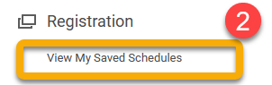
To prepare for registration,

- Select course sections needed for the academic term,
- Create a saved schedule and save courses to the saved schedule,
- Register from your saved schedule after the registration window opens

Saved schedules allow you to prepare a class schedule BEFORE registration opens. Use this reference to register from your saved schedule AFTER registration opens.

Once successfully registered, you will land on a confirmation page and be immediately registered for all the course sections in your saved schedule.
This page will also signal if you are waitlisted for any course section.
INSTRUCTIONS
- When the registration window is open, login and enter the Academics app.
- Click “View My Saved Schedules” under the Registration heading.
- Click the academic period of your saved schedule and click “OK”.
- Click “Edit” to make final changes to your schedule.
- To make sure your schedule is right for you, click “Calendar View” and your schedule will display as a calendar.
- When you are ready to register, click “Start Registration”.
- Click “Register”

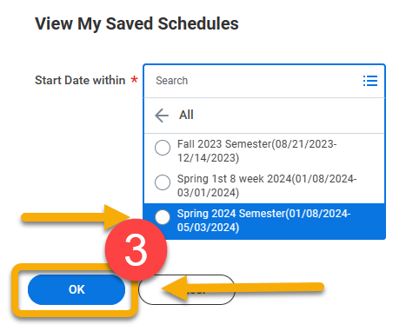

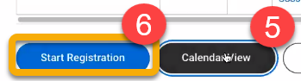

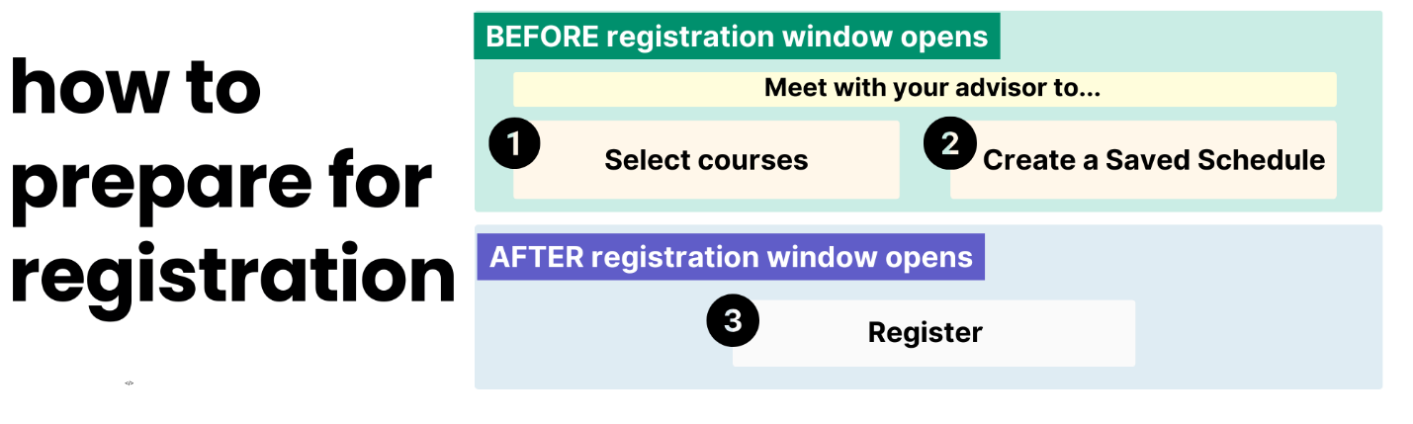
Save time and avoid mistakes by registering from a saved schedule.
Saved schedules allow you to prepare a class schedule BEFORE registration opens. Then, AFTER registration opens you can register for all the classes in your schedule as a group, instead of registering each course individually.

Use this reference to:
- Register from your saved schedule (recommended)
- Register for individual classes

TIP: To complete these steps, you must already have a saved schedule prepared. If you do not have a saved schedule, meet with your advisor.

Register from a Saved Schedule
- Log into Workday and click the Academics app.

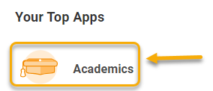

- In the Academics app, click “View My Saved Schedules” under the Registration heading.
If you do not have a saved schedule, meet with your advisor.

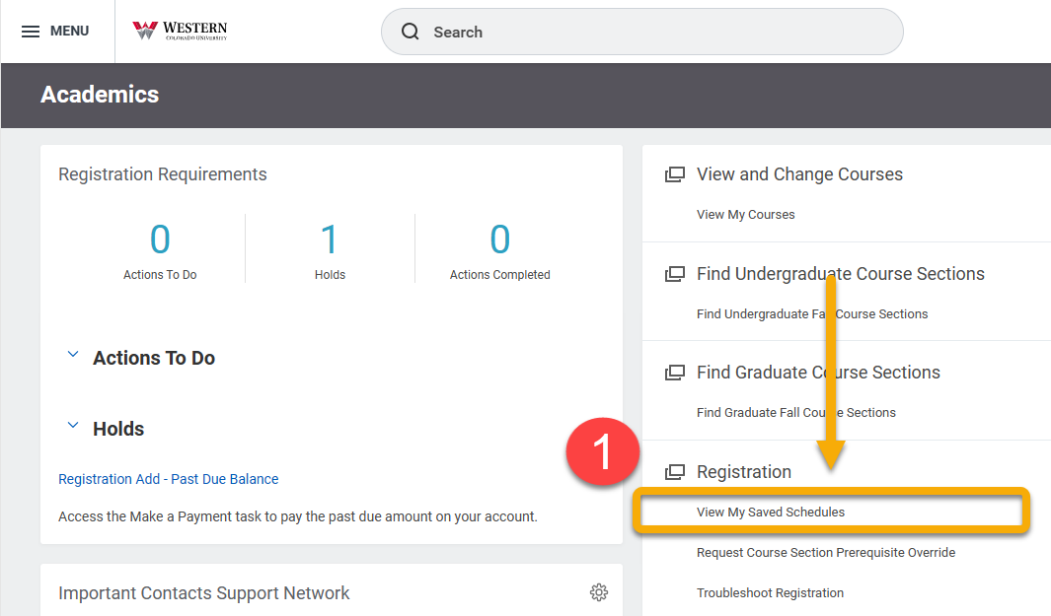

Select the academic period associated with your saved schedule and click “OK”.
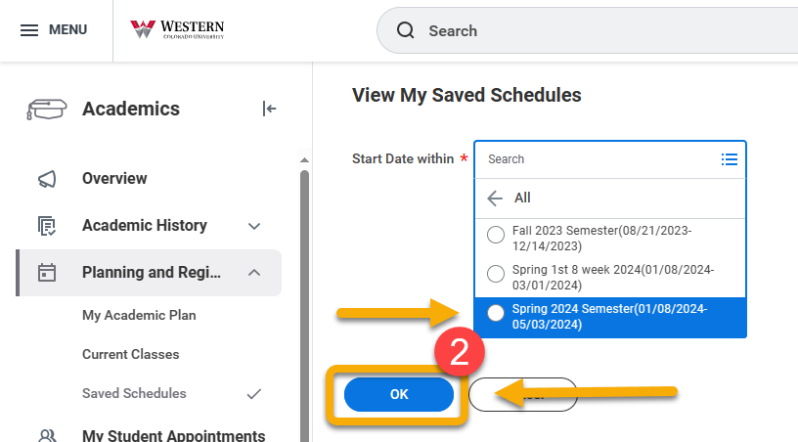

On the View My Saved Schedules page, you will see all your current and previously saved schedules. Find the saved schedule from which you want to register.

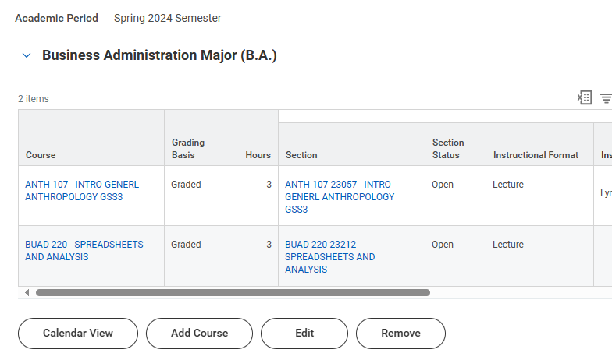

There is a row of helpful buttons at the bottom of each saved schedule. Click “Edit” to make final changes to your schedule.

If you want to add a course, return to the Academics app homepage and click “Find Undergraduate/Graduate Course Sections”.

 The “Add Course” button is not recommended.

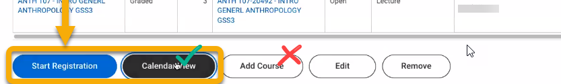

The “Calendar View” button is very helpful. To make sure your schedule is right for you, click “Calendar View” and your schedule will display as a calendar.
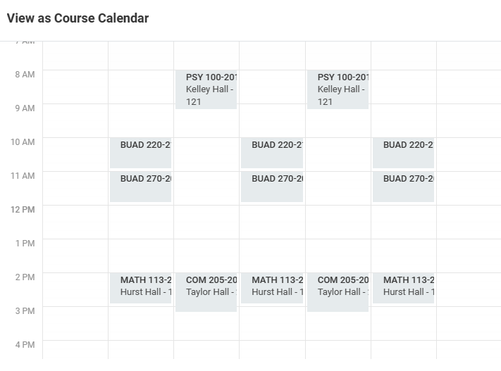

When you are ready to register, return to the list view of your saved schedule and click “Start Registration”.
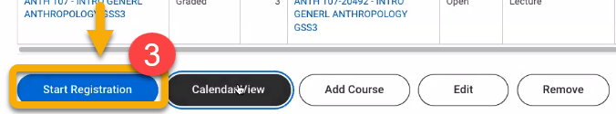

Click “Register”.

Once successfully registered, you will land on a confirmation page and you will be immediately registered for all the course sections in your saved schedule. This page will also signal if you are waitlisted for any course section.

To review your registration, click “View Registered Courses”.
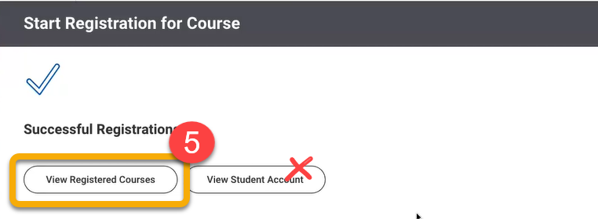


Do not click “View Student Account”. This will take you away from registration.

